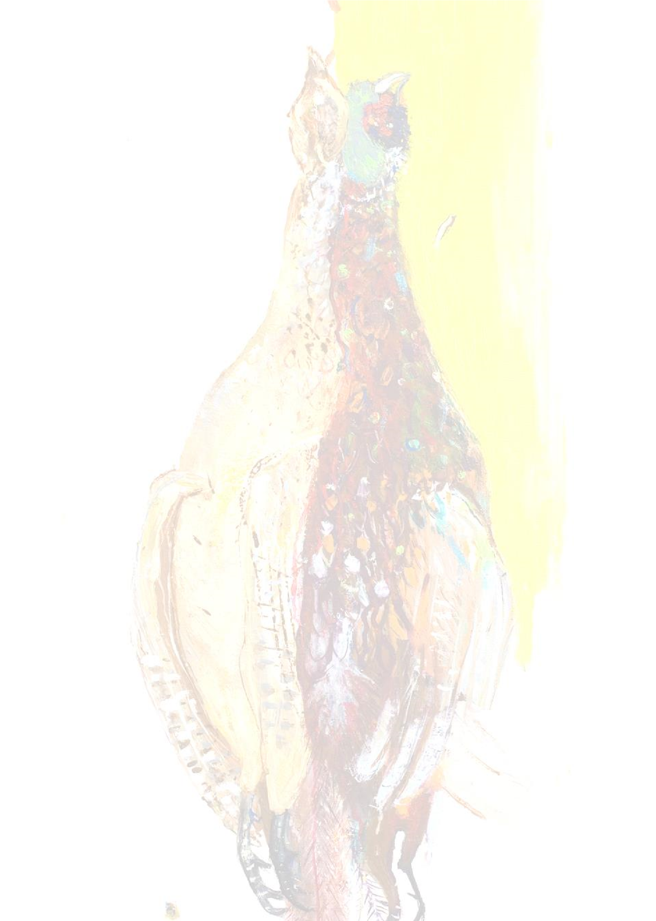


LOCAL AND WILD MENU
£48

(ADDITIONAL WINE PAIRING £38)

SNACKS

MUSHROOM MARMITE ÉCLAIR, EGG CONFIT, CORNICHON

SARDINE CROQUETTE, PICKLED ONION EMULSION

NUTTY WILD, NV, NUTBOURNE VINEYARD, ENGLAND

garden patch

HACKNEY BURRATA, NUTBOURNE TOMATO, CHIVES, ALMOND

SUSSEX RESERVE, NUTBOURNE VINEYARDS, ENGLAND

SEA

CURED TROUT, DILL EMULSION, TROUT ROE, NORI

ASSYRTIKO PAPAIOANNOU, NEMEA, GREECE

FIELD

TEMPURA MARROW, GARLIC & HONEY, PECORINO

REINARES TEMPRANILLO, VINO DE LA TIERRE DE CASTILLA, SPAIN

FARM

PORK TENDERLOIN, OYSTER MUSHROOM, SPRING ONION, BRAISED FENNEL

BEAUJOLAIS – VILLAGES, FLEURIE, FRANCE

DESSERT

CHEESECAKE, WHITE CHOCOLATE, WILD BERRIES

LES LIONS DE SUDUIRAUT, SAUTERNES, FRANCE
Please note that a discretionary service charge of 13.5% will be added to your bill.
Kindly inform us of any allergens when ordering your meal.

